

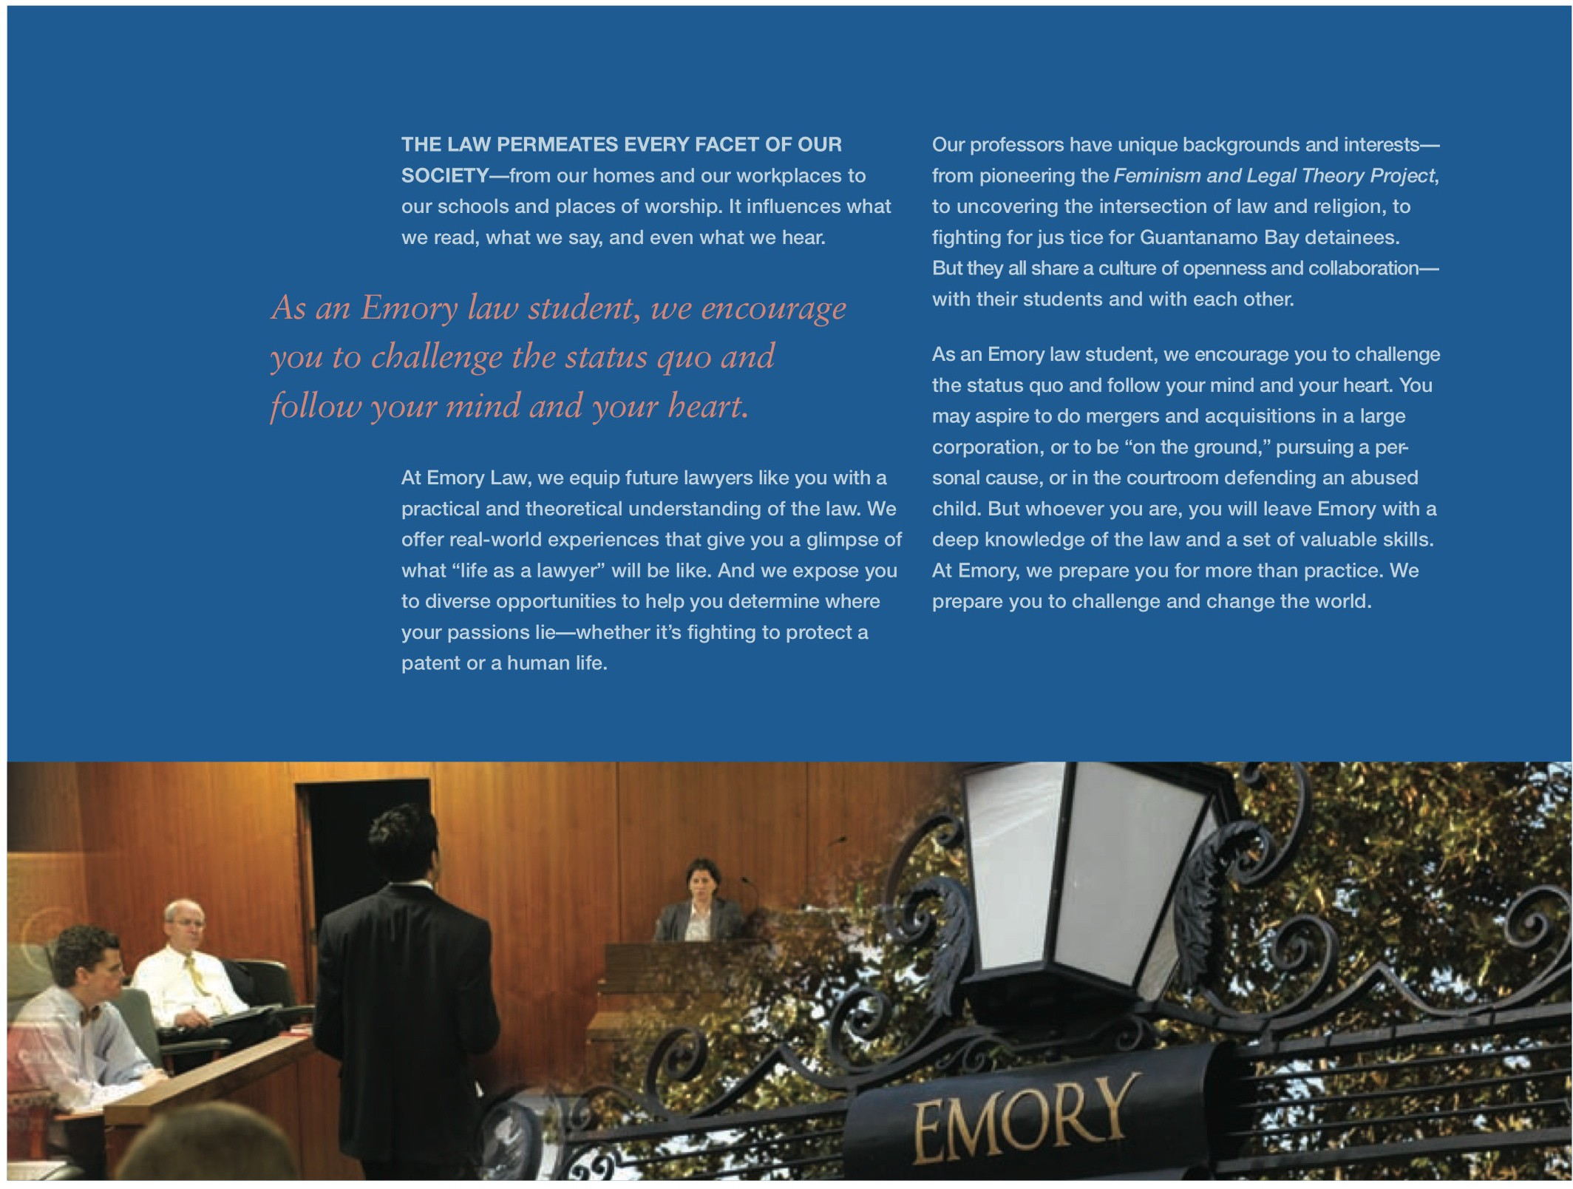

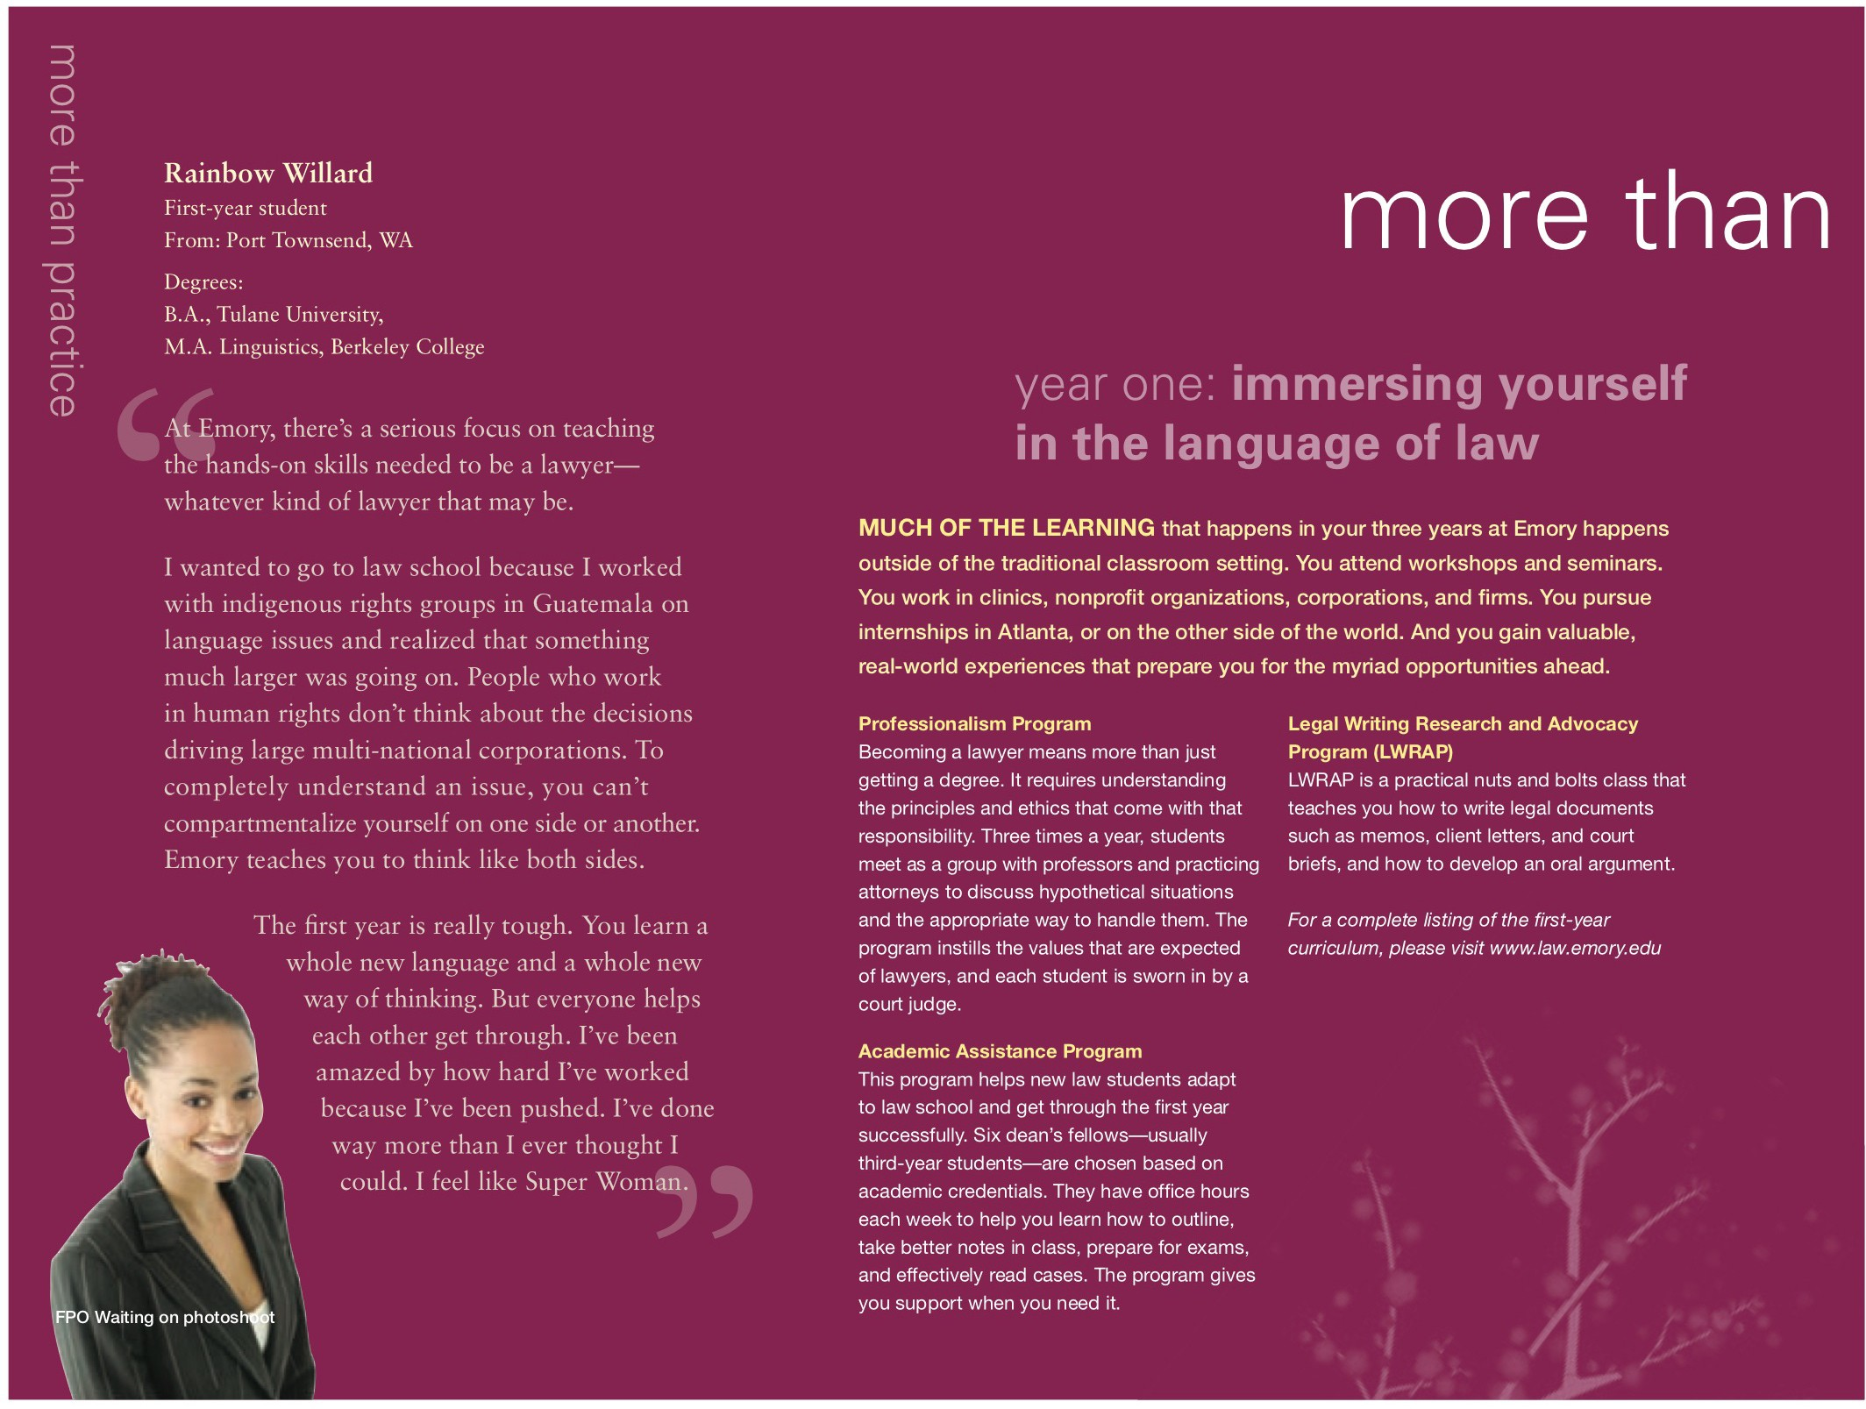







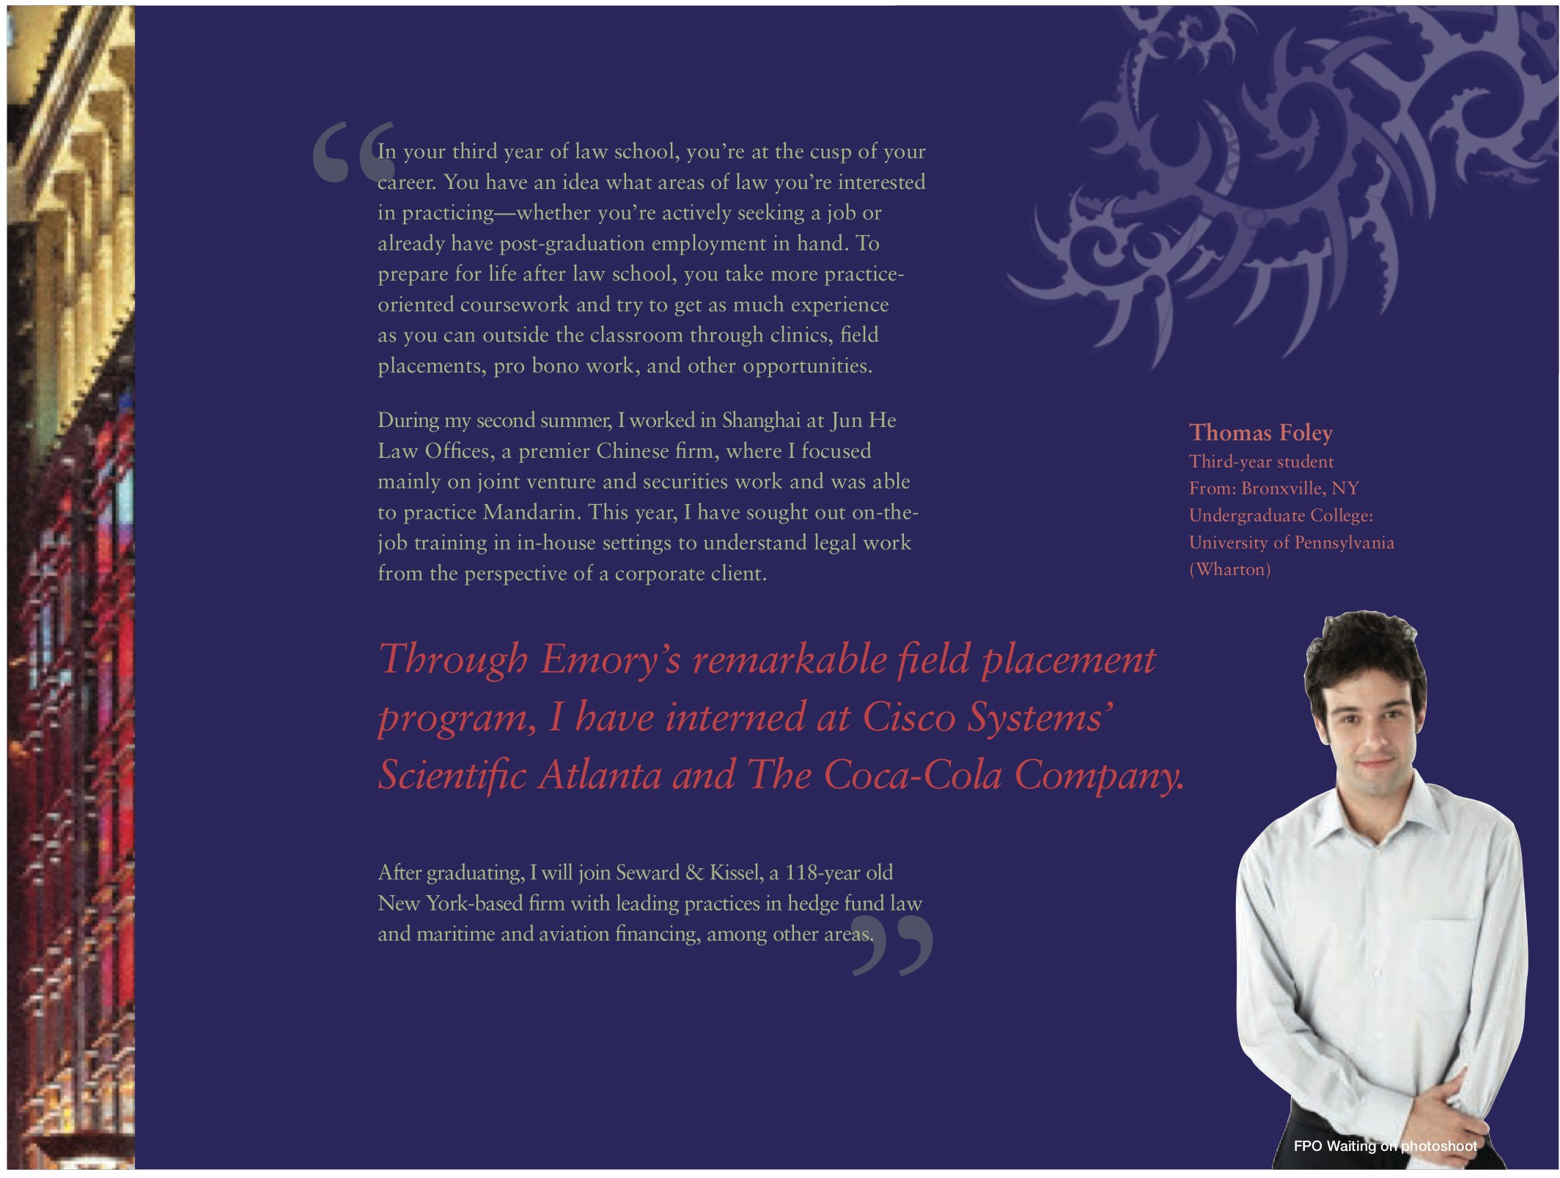



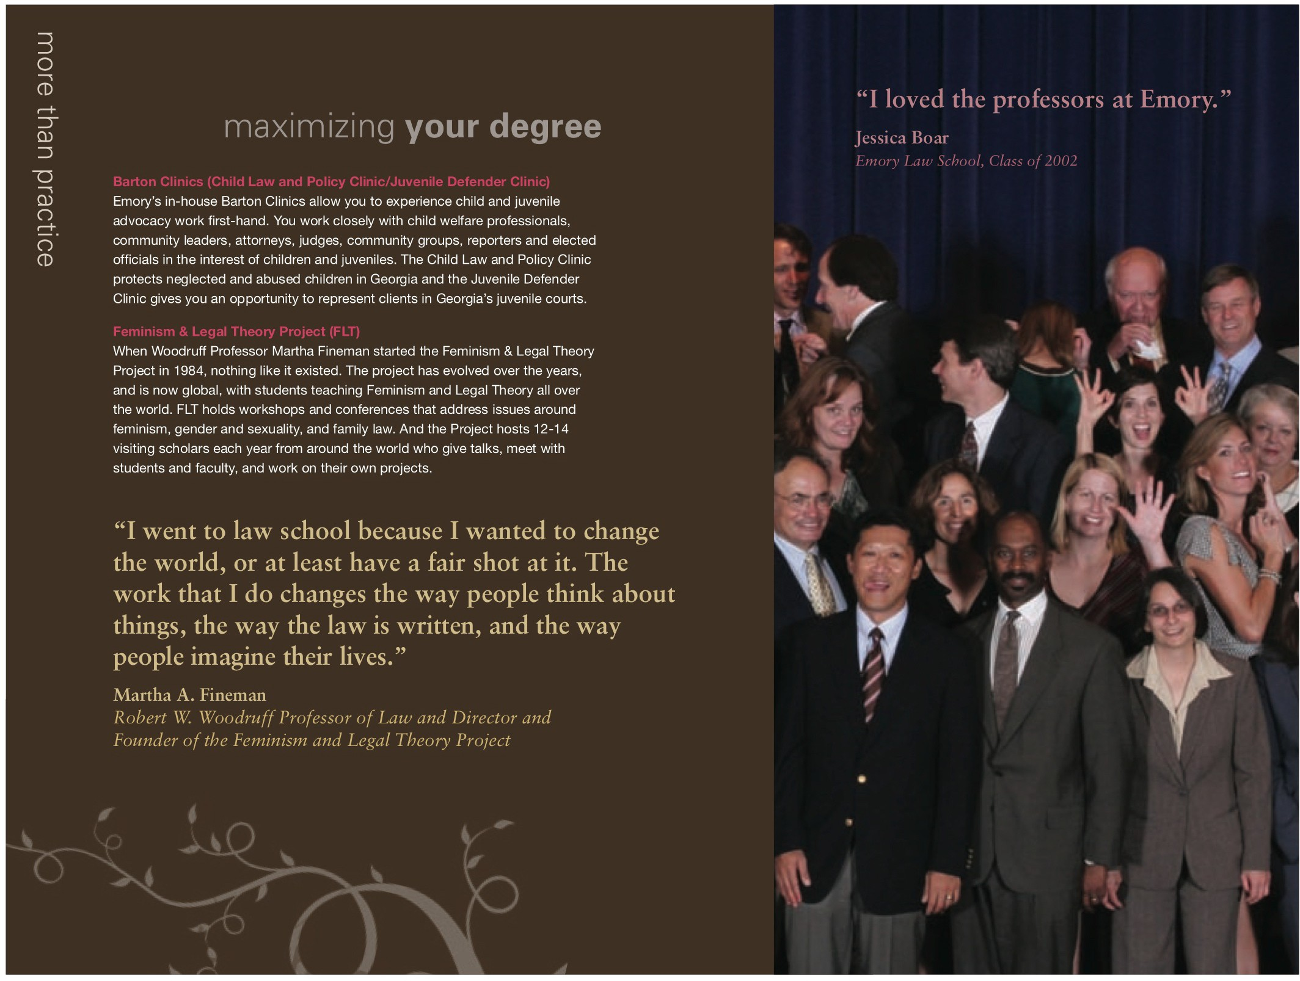



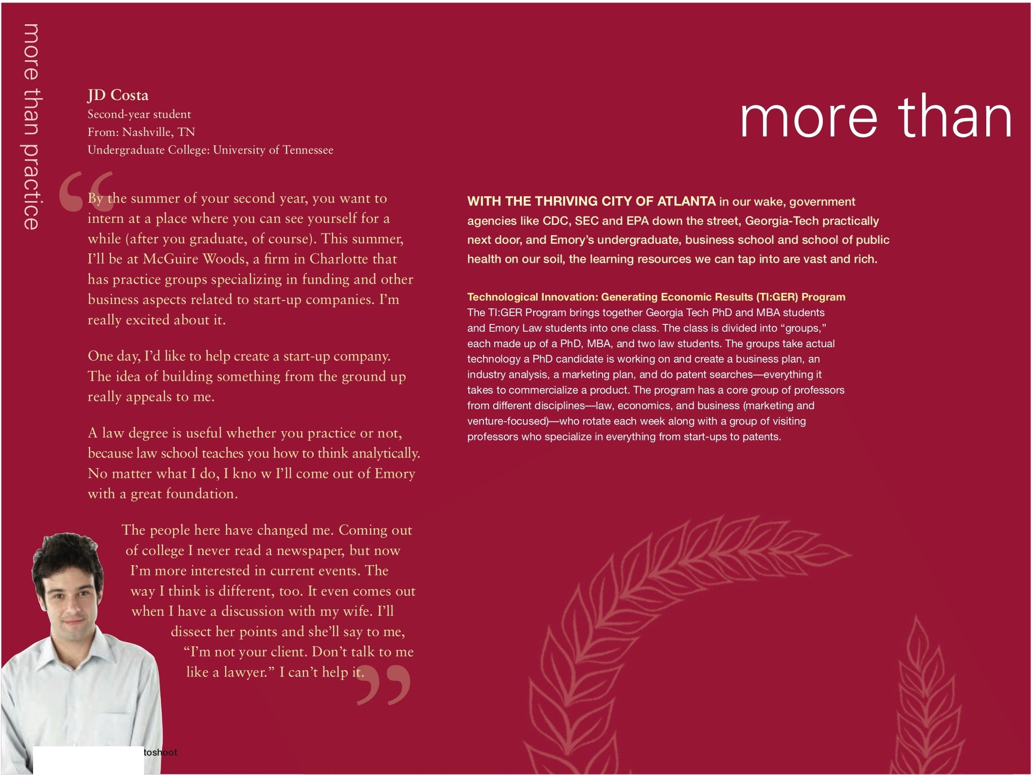

FPO Waiting on ho











\8) EMORY I LAW
Emory University School of Law 1301 Clifton Road
Atlanta, Georgia 30322
P 404.727.6802
www.law.emory.edu

more than practice



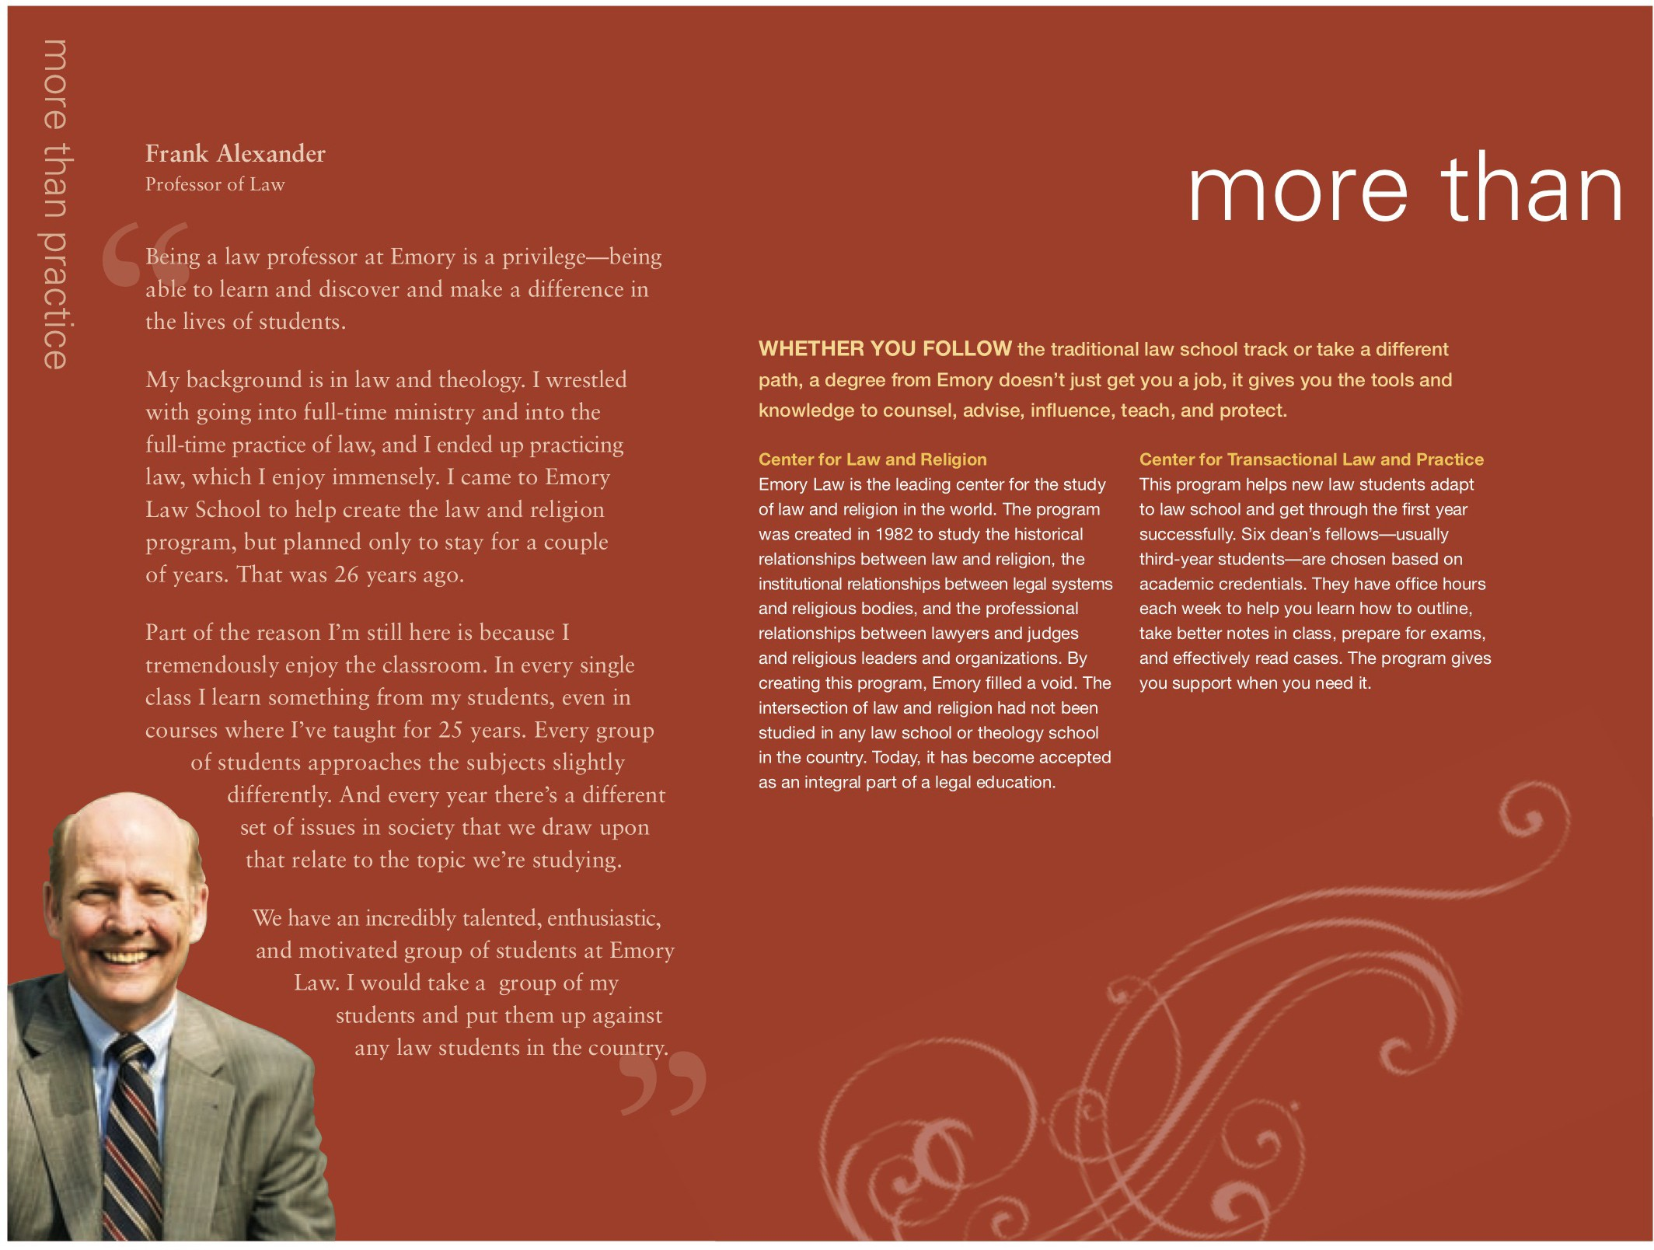





After law school I wanted to stay in Atlanta-I didn't feel like I had to. Now, I live right outside of the city. I have a 10-minute drive to work and I'm in an affordable house with a yard and a neighborhood. You can't get that in the northeast.
Chris Bly
Emory Law School Alumnus, Class of 2002

I love Atlanta. It's just like Emory. It's open, dynamic, inclusive, diverse, exciting. Just this past week I went to a prize-winning play at the Alliance Theater by a young African-American. I went to the Big Apple Circus in Stone Mountain. I went to see the Kronos Quartet at the Schwartz Center and I went to a ballet performance of Romeo and Juliet, choreographed by Michael Pink. That's my
weekend. I don't think I could do better in any other city in the world.
Martha A. Fineman
Robert W. Woodruff Professor of Law and Director and Founder of the Feminism and Legal Theory Project

Atlanta is one of the most fascinating metropolitan areas of the country because of its diversity-racially, culturally, economically, and geographically. We still have a lot of inner city neighborhoods with trees and land. We're an international city, but also a southern city. We have many of the challenges that face urban America, but we also have a delightful naivete and enthusiasm that things can be made better.
Frank Alexander
Professor of Law


In addition to the standard JD offered for completing three years of Emory Law School, Emory's joint degrees offer you the opportunity to specialize in additional areas of the law that most interest you. You must be admitted to both Emory

Law and the programs listed below.

:
..
. .




..
..
..


. . .
. .
. - ....
..-.
.. .
.

